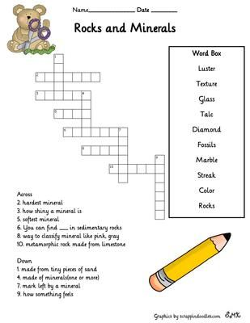

Relate the two columns:
Diamond 1. Rock formed by three minerals
Eraser 2. Gypsum
Granite 3. Clay
Quartz, Feldspar and Mica 4. Sedimentary rock
From it you get the lime 5. Measuring the hardness of minerals
When wetting it can be modeled 6. They are the minerals of granite
From it you get plaster 7. It is a precious and very hard mineral
Used in the Stone Age 8. It is not mineral or rock
Sandstone 9. Limestone
Mohs Scale 10. Flint

Solutions:
2. hardest mineral Diamond
3. how shiny a mineral is Luster
5. softest mineral Talc
6. you can find _fossils_ in sedimentary rocks
8. way to classified minerals like pink, grey. Colour
10. metamorphic rock made from limestone Marble.

1. made from tiny pieces of sand Glass
4. made of minerals (one or more) Rocks
7. mark left by a mineral Streak
9. how something feels Texture

Diamond 7
Eraser 8
Granite 1
Quartz, Feldspar and Mica 6
From it you get the lime 9
When wetting it can be modeled 3
From it you get plaster 2
Used in the Stone Age 10
Sandstone 4
Mohs Scale 5

