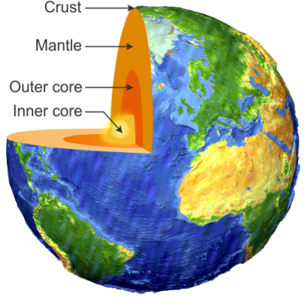
UNIT 3_ The Geosphere
1. The internal structure of the Earth
The Earth is a rocky planet with a metallic core.
It has a radius of 6370 km
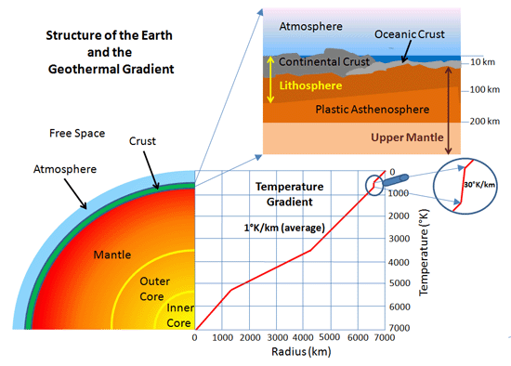
Its temperature increases with depth: 3ºC / 100 m. The inner core’s temperature is near to the Sun’surface temperature.

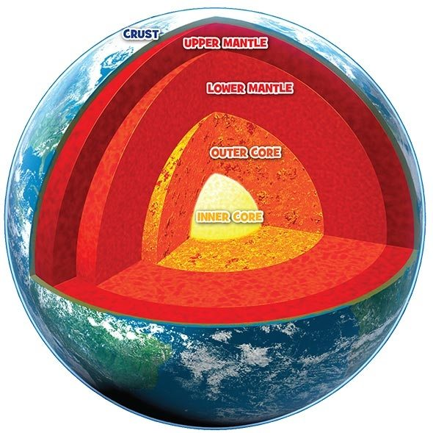
Temperature, density and pressure increase with depth.
Read page 58.

Earth’slayers | Thickness | Composition | States of matter
Continental crust | 10 to 80 Km | Plutonic rocks (granits), sedimentary and metamorphic rocks. | Solid. Forms continents and continental shelfs
Oceaniccrust | 5 to 15 Km | Volcanic rocks (basalts) in the upper zone and plutonic rocks (gabbros) in the lower zone. | Solid. Formtheseabed
Upper, middle and lower Mantle | 2900 Km | Peridotites rocks (silicates of iron and magnesium) | Solid and semisolid. There are convection currents
Outercore | 2200 Km | Iron and nickel | Liquid. Convection currents generate magnetic field.
Inner core | 1270 Km |  | The hottest layer and by high pressure is solid.
Convention currents: hot molten material rises to the Surface and sink again when it cools.
Make the model of the Earth’s layers. You need:
- 5 paper circles
- Scissors
- Glue
- First paper: draw the Earth: Eurasia, Africa and Australia
- Second paper: Fold by the centre line of points. Paint in the right half, the continental crust with light pink and the oceanic crust with light purple.
- Third paper: Fold by the centre line of points. Paint in the right half the mantle with orange color.
- Fourth paper: Fold by the centre line of points. Paint in the right half the outer core in red and the inner core in yellow.
- Stick the left half of each paper over the fifth paper.
- Write the characteristics of each layer on the left half of each paper.
Page 59. Act. 3 and 4.

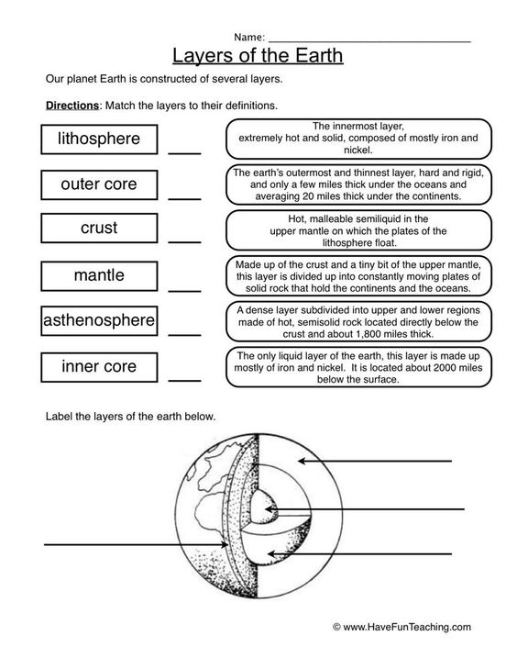

You have to prepare a “show and tell” about something related to the unit for next week.
2. Minerals
- What is the difference between minerals and rocks?
Minerals have a specific chemical structure. Rocks are composed of a variety of different minerals.
- What are minerals?
Mineral are solid naturally occurring inorganic substances with a fixed chemical composition.
- Solid - solids at normal temperatures on Earth’s surface.
- Naturally occurring – Not made in a chemistry lab .
- Inorganic - Minerals don't come from living things.
- Fixed chemical structure – Specific minerals have the same combination of elements. Minerals generally have a crystalline structure, except in some cases where crystals are not formed regularly, named amorphous structure.
Scientists have classified more than 3000 minerals.
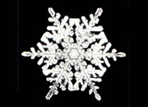
Did You Know? Although liquid water is not a mineral, it is a mineral when it freezes. Ice is a naturally occurring, inorganic solid with a definite chemical composition and an ordered internal structure.
Some minerals are important as raw materials in industries or as ores that are minerals from which a metal can be extracted. Examples:
Iron from haematite or magnetite.
Alumnium from bauxite
Lead from galena
Tin from casseterite
Copper from calcopyrite
- The extraction of minerals:
When they are found concentrated in mineral deposits, named mines. They can be:
Underground mines, where minerals are extracted from below the Earth’s surface. From layers or seams.
Open-cast mines, where minerals are obtained from the Earth’s surface. Dispersed in different places.
Pag. 61 act. 5.
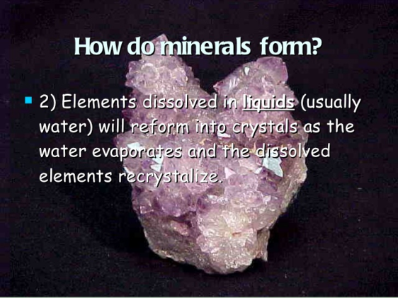
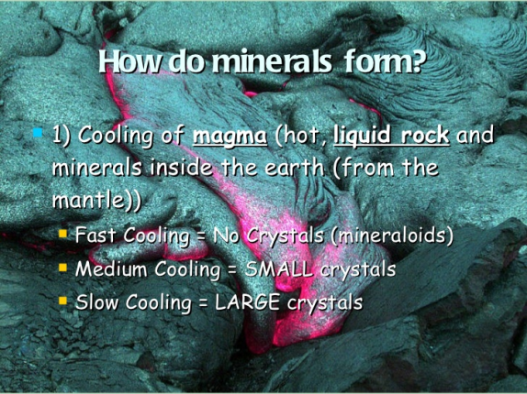
- 3. Minerals and their properties.
DENSITY: It is the relationship between the mass of a mineral in grams and its volume in cubic centimetres. D=M/V
COLOUR: Some minerals have a characteristic colour: from transparent or colourless to colourfull. Some minerals can have different colours, like quartzs: rock crystal, milky quartz or amethyst.
COLOUR STREAK: The powder of the mineral left after streaking over a porcelain plate. The colour of the streak can be different tha the mineral. It is characteristic for each one and can be used for identification.
HARDNESS: It is the resistance of the mineral to be scratched or the ability to scratch other minerals.
Hardness is measured using the Mohs scale. Ten minerals. Each mineral is able to scratch the one below it, and be scratched by the one above it.

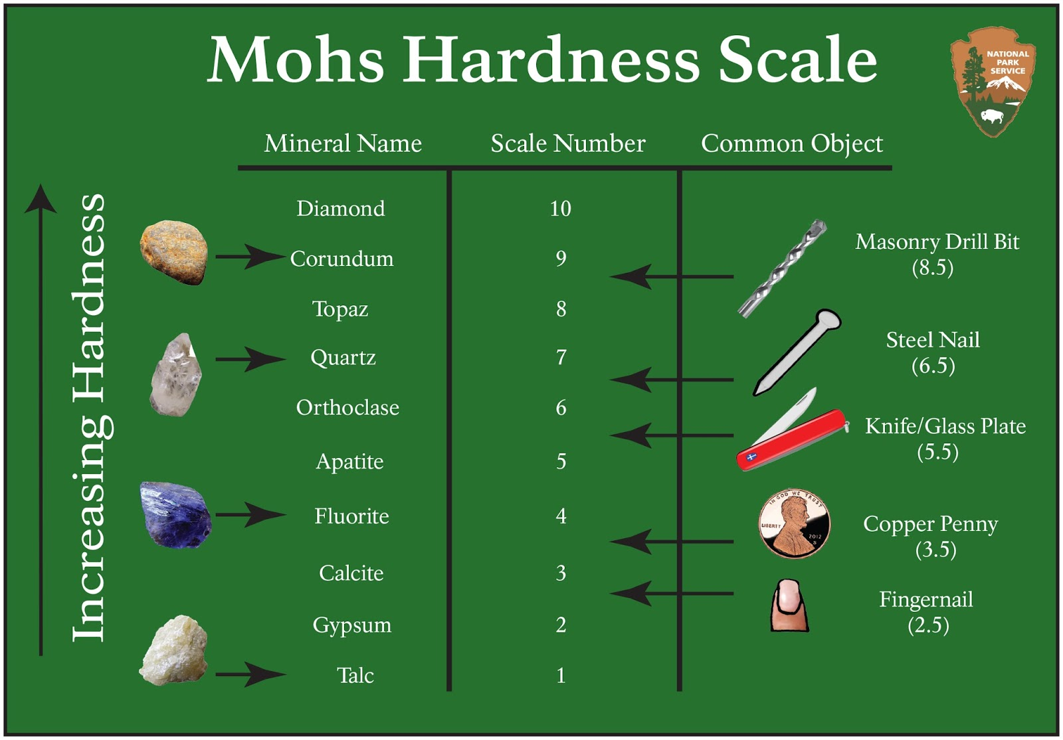

Lustre: The way minerals reflect light. It can be:
Metallic
Non-metallic: vitreous or glass-like, greasy, pearly, silky, etc.
Crystal shape: The general shape of a mineral:
Well-developed crystas (cubes like in common salt, rhombohedrons like in copper sulphate, …)
Fibrous appearance (gypsum)
No apparent crystals (opal, silex, …)
CLEAVAGE: The way a mineral is separated into flat side fragments when it breaks.
FRACTURE: When minerals no not cleave, fractures can be conchoidal, fibrous, etc.

You can check here:
https://www.slideshare.net/cmerkert/minerals-slideshare

- 4. USING MINERALS:
- Obtaining metals:
  - Copper from chalchopyrite. Copper is the most commonly used metal in the manufacture of cable and electronic components.
  - Titanium from rutile. Titanium because of it is light, resistance to corrosion and strong, it is used in the aeronautical industry and to repair bone fractures.
Match these two columns:
Copper 1. Rutile
Aluminium 2. Magnetite
Iron 3. Bauxite
Lead 4. Chalcopyrite
Titanium 5. Casseterite
Tin 6. Galena

- Obtaining sulfuric acid from Pyrite
- In mobile telephones and electronic devices: coltan. It is a mixture of two minerals: columbite and tantalite.
- To make glass: Quartz
Watches, digital and optical instruments, photovoltaic panels….
- As gemstones, when cut and polished:
  - Precious stones: diamond, ruby, sapphire and emerald
  - Semiprecious stones: topaz, aquamarine, turquoise, ….
- Salts:
  - From halite, It is used to conserve and flavour foods.
  - From fluorite in toothpaste.
- Nuclear fuel to generate electricity: Uranium obtained from uranite
- Pigments: Green from malaquite, blue from azurite

Activities 2 and 4 of page 65.
https://www.youtube.com/watch?v=hnyHzTvBZnU

- 5. ROCKS.
Material that consists of one (quartzite) or more minerals (granite).
Classification of rocks according to the geological process of formation.

IGNEOUS OR MAGMATIC ROCKS
Formed from magma (molten material in the Earth’s interior). When this material comes up to the surface is called lava. There are two types of igneous rocks:

Plutonic rocks: slowly cooling of magma and solidifies at depth. Minerals bound together. Ex: Granite (with mica, feldspar and quartz). They form most of the continental crust.

Volcanic rocks: when lava cools and solidifies quickly on the Earth’s Surface. They can have minimum crystals growth in a black glassy substance called obsidian. Ex: basalt (the most common in the oceanic crust), pumice (pumice stone)

SEDIMENTARY ROCKS
These are formed from sediments accumulated in the bottom of sedimentary basins. Types of these rocks:

Detrital rocks: When sediments derived from fragments or grains broken off rocks by erosion, transported and accumulated. They are compacted, cemented and form detrital rocks. Three types according the size of grains:
Conglomerates (Larger)
Sandstones (Medium). Usully quartz grains.
Clay (Smaller)

Saline rocks: When sediments derived from salts precipitated after evaporation of water. The most important are:
Gypsum
Common salt

Limestone rocks: When sediments consist mainly of calcite. They bubble with the acid. They can be originated from:
Remains of living organisms such as shells and skeletons of calcium carbonate: fossil limestone, travertine.
Calcite precipitated producing stalactites and stalagmites in caves.

Organic rocks: When sediments derived from plants and animals remains buried and transformed by bacteria, millions of years ago.
Coal (mostly is carbon): From great forests living in a warm and humid period (carboniferous): Peat, lignite, bituminous coal and anthracite.
Oil and gas : From marine plankton.

METAMORPHIC ROCKS
These come from the transformation of other rocks, subjected to strong pressures or high temperatures inside the Earth and always in solid state.Process called metamorphism.
Types of these rocks:
Laminars, texture in foliation, are separated into parallel planes, caused by the pressure.
Slate and schist formed from the clay
Gneis from the granite.
Crystalline, they are not separated into sheets
Quartzite from sandstone
Marble from limestone. Bubble with the acid.
Activities 4 and 5, pag 67. And 1 and 2 of pag 69.
- 6. THE ROCK CYCLE
https://www.youtube.com/watch?v=53lMdHzvGCQ
https://www.youtube.com/watch?v=r68iEwYdbh4
Complete the diagrama using these words and others from yourself:
Heat and pressure. Melting. Cooling. Weathering and erosion.
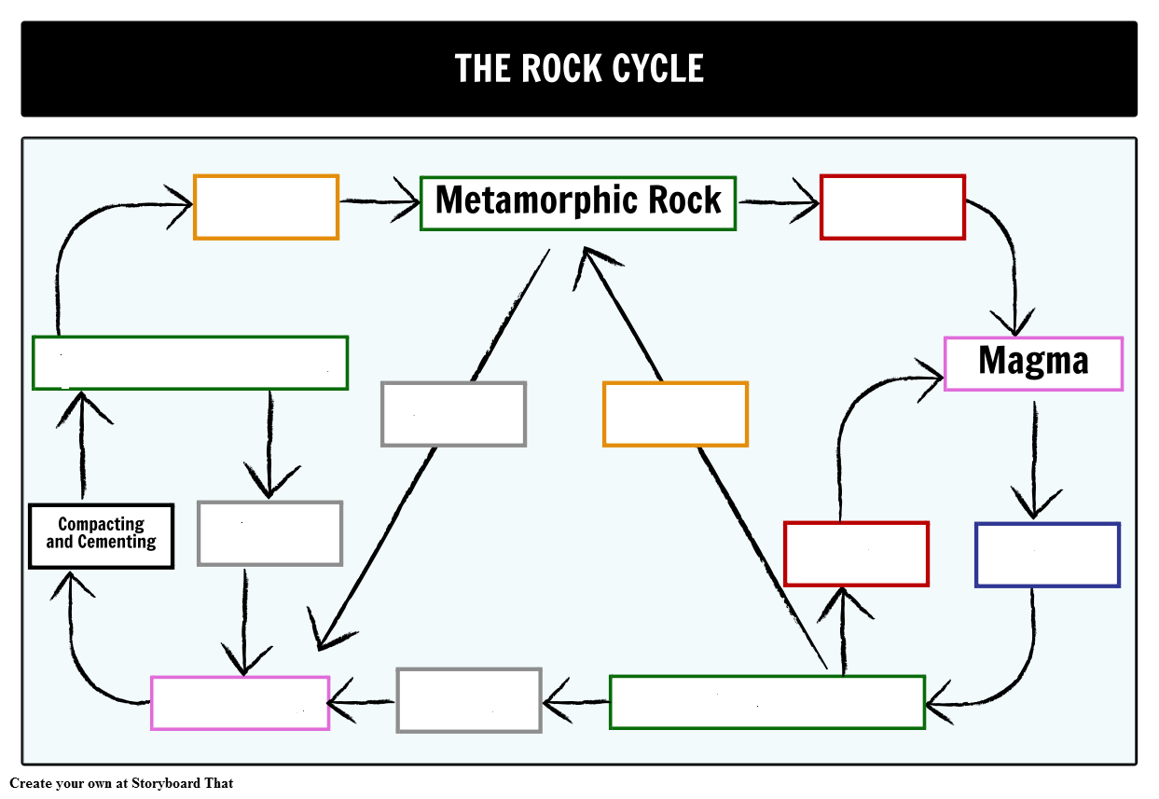
- 7. Mining and the use of rocks.
- Quarry: Large open hole cut into the ground from where rocks and construction materials are extracted.
- The use of rocks.
  - Sedimentary rocks
    - Salts in the food industry and for detergents.
    - Gypsum to make plaster.
    - Sand or gravel for surfacing roads.
    - Clay to make bricks, tiles, pottery.
    - A mixture of limestone and clay heated at high temperatura to make cement. Mixed with gravel makes concrete.
  - Magmatic rocks
    - Granite as paving stone.
    - Obsidiane in decoration and jewellery
    - Pumice in aesthetic.
  - Metamorphic rocks:
    - Slates, in roof construction
    - Marble in construction, ornamentation and sculpture
As a review, activities 1 and 2 of page 75.
- pag 73. Analyse a text: Transforming abandoned quarries. As homework and for mark.

