BIOSPHERE
PART 1
As introduction to cells:
https://www.youtube.com/watch?v=gFuEo2ccTPA
- They are all made up of

Cells, either only one (unicellular organism) or more (pluricellular)
- They do the vital functions: (nutrition, intercation and reproduction)
- They all have a similar composition
- Biolelements: C, H, O, N, P (Phosphorus), S (sulphur)
- Biomolecules:
  - Inorganic biomolecules:water and mineral salts
  - Organic molecules: Carbohydrates, Fats or lipids ,Proteins and Nucleic acids.
What elements are part of living matter?
What are the functions of carbohydrates and what foods can we find them in?
What are the functions of lipids and what foods can we find them in?
What are the functions of proteins and what foods can we find them in?

VITAL FUNCTIONS
https://youtu.be/L_zaTnh8LXo
NUTRITION
- Autotrophs (they CAN produce their own organic compounds),
either they get Energy from the SUN: PHOTOSYNTHESIS
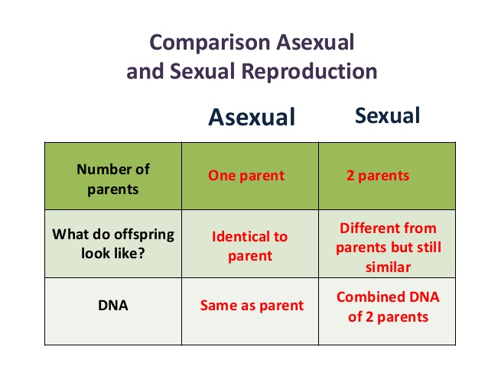
or from Chemical _Ractions: CHEMOSYNTHESIS
- Heterotrophs (they cannot produce their own organic compounds)
INTERACTION
Response to a change in the environment.
STIMULUS --RESPONSE
REPRODUCTION
- Sexual: 2 individuals needes (male + female) , 2 sexual cells (GAMETES), diverse offspring generated
- Asexual: only ONE individual implied / genetically identical offspring
Learn singing https://youtu.be/rABKB5aS2Zg
What are cells?. Write the difference between unicellular and multicellular beings .
Do activities part 1.
You can review the differences and similarities between prokaryotes and eukaryotes, and between animal an plant cells.
https://www.youtube.com/watch?v=URUJD5NEXC8
Draw a bacterium with its parts.
Describe an eukaryotic cell
Make a chart with similarities and differences between animal and plant cells.
Components | Prokaryote | Animal eukaryote | Plan eukaryote
Cytoplasm
Chloroplast
Cell membrane
Nucleus
Mitochondrion
DNA
Lysosomes
Centrioles
Golgi apparatus
Endoplasmic reticulum
Ribosomes
Cell wall

Levels of life organization:
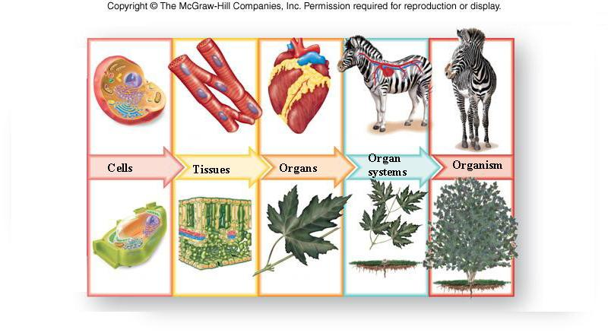
What is tissu made from? Give examples.
What are organs made of? Give examples.
Finally do activity 1 of page 129.

