Laboratory activity
LEARNING ABOUT MINERALS’PROPERTIES
Objective: Use mineral’s properties to identify minerals.
MATERIALS:
Minerals
Graduated cylinder, electronic balance, watch glass, beaker, glass rod, streak plate or porcelain glass, slide, Petri dish, steel nail, coin.
Stereoscope.
Procedure
- Density: D=M/V
Measure the mineral’s volume using a graduated cylinder and water.
Put 200 ml of water in the cylinder (the lower surface of the meniscus) and then carefully put the mineral inside. Vmineral=Vf-Vo
Weigh the mineral ‘mass using the electronic balance over a watch glass. You have to tare the watch glass
- Crystalline structure:
Prepare a saturated solution of common salt/copper sulphate:
Put 100 ml of water in the beaker. Take common salt / copper sulphate powder and add to the water. Move with the glass rod to solve and add more powder. Repeat until no more admission.
Let precipitate the unsolved powder and then pour it into a Petri dish. Wait 24 h or more.
Observe the formed crystals using a magnifying glass. Draw the obtained crystal’s shapes.
- Colour:
Observe the mineral’s colour and note in the table.

- Colour streak:
Observe the mineral powder colour streaking over the porcelain glass and note in the table. The colour of the streak can be different of the mineral.

- Hardness:
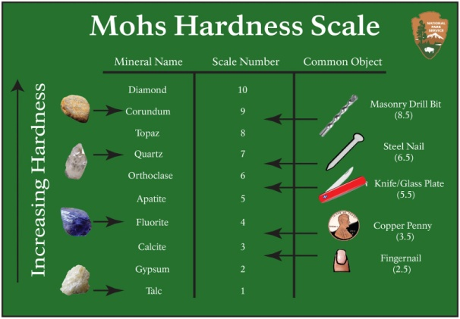
You have to use firstly your fingernail to scratch the mineral (1-2), then with a coin (3-4), with a knife (5-6), a crystal (slide) (5-7) o finally if the mineral can scratch the crystal (7-10)

- Luster:
Observe the way light is reflected: can be metallic, vitreous or glass-like, pearly, silky, greasy, etc
RESULTS:
Densitiy:
Crystallization:
Other properties:
Mineral | Colour | Luster | Hardness | Colour streak | Curiosities
Gypsum
Galena
Pyrite
Talc
Quartz
Magnetite

DISCUSSIONS AND CONCLUSIONS:

