Unit 5. The hydrosphere.
INTRODUCTION
https://www.youtube.com/watch?v=0q0ApYZrMTk
The presence of liquid water on theEarth’s surfacemakes our planet unique in the Solar System.
Overpopulation in the world results in water pollution.
CONCEPT
The hydrosphere is the combined mass of all the water on the planet: seas, oceans, surface water on the continents, groundwater and glacial ice.
Water covers about three quarters of the planet’s surface.
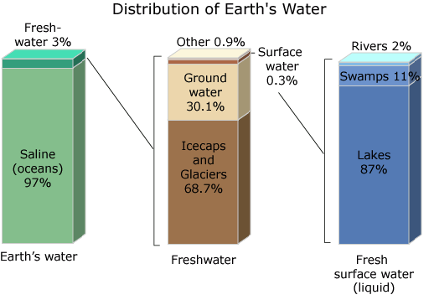
1. Water cycle: Relate with the changes of water’s state
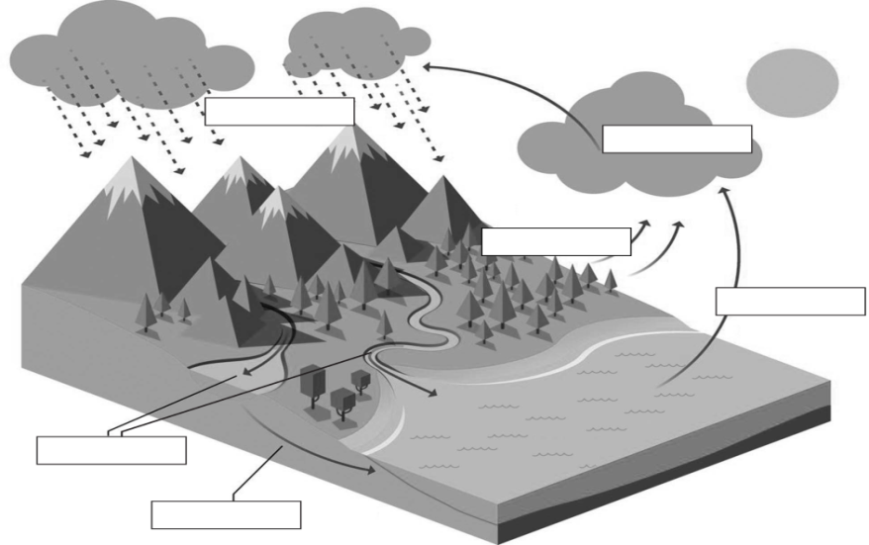

The water we use comes from groundwater layer or aquifers, lakes and rivers.
What are the goundwater layers or aquifers?

Tell your partner
Natural disaster could happen:
Floods
Droughts
What happens when rivers overflow?

What happens after a long absence of rain?

Tell your partner

2. Water is necessary for life:
ALL THE LIVING THINS CONSIST MAINLY OF WATER: Write the percentage:
____% human beings
____% marine animals
____% woody plants
Read “the properties of water”
Relate the properties of the water with its functions. Youhave to copy
- Water exists in three states allowing the water cycle to occur. It can be absorbed as liquid and returns to the air as vapour.
- It is highly solvent, so:
  - Many biochemical reaction occur in a watery environment or can be taken in processes like photosynthesis.
  - Dissolves and carries essential substances for feeding cells and helps to eliminate waste substances (in urine or sweat)
- Ice can float on liquid water because it is not as dense, so many living things can develop under ice.
- Water can absorb a lot of heat but its temperature only rises slightly, so water keeps our internal temperature constant.
- Water molecules bond tightly together enabling insects to “walk” on it.
3. Water is a precious resource.
- How water is used? Discuss about them without book. After that read them: pag 100
  - Agriculture
  - Public
  - Domestic
  - Recreational
  - Livestok
  - Industrial
  - Transport
  - To generate electricity,
What are the reservoirs?
It is an artificial lake, a place where water is kept, after building a barrier o dam across a water way such a river.
What are their uses?
Their uses are for human consumption, watering and to produce electricity.
- As the availability of water is limited, it is essential avoid wasting it, prevent its pollution and encourage water recycling:
3.1 Ways to save water. Watch
https://www.youtube.com/watch?v=9NSE-mii9PA
https://www.edenproject.com/learn/for-everyone/water-saving-tips
Discuss about it and then read. Pag 101.
https://www.youtube.com/watch?v=As_hxqf7sRY
3.2 Water can be polluted by:
- Sewage, waste water, water from human houses, farming or other buildings. It contains s lot pathogenic microorganisms.
- Chemical products (solvents, heavy metals, detergents…) from houses, industries and farmings.
- Solid objects: tins, plastics.
- Unused medicines
- Energy sources as the hot water used as cooler agent in nuclear plants.
Pollution can occur at a specific site (urban and industrial waste) or can be diffuse without a clear source (agricultural waste).
In some places (developing countries) waste water is thrown into rivers lakes and seas.
Read marine pollution and discuss about the amount of toxic substances, plastics and oil slicks from crude oil spills during its extraction or transportation. They can kill marine life.

Fill the gaps with these words:
Springs, SOURCES, Desalination Plant, Water collection, Reservoirs, Water purification, Fountains, Distribution networks, uses, Wells, sewerage system, sewage, Rivers, Waste water treatment, irrigation, Lakes

3.3 The urban water cycle.

________or catchment
_________
_________
_________
_________
_________
_________
A _______ __________ takes the waste water (_______) to the treatment plant
_________ ________ to ellimnate pollutants before returning it to the natural environment
Chemical treatment
Storage in tanks
_________ _________ (pipes) to supply purified water for urban _______
____ _________to make it safe for drinking

Sea

Some of the treated water is reused for ________ and for cooling systems
Waste such as solids, sand, fat and organic matter

Fill the gaps with these words:
Springs, SOURCES, Desalination Plant, Water collection, Reservoirs, Water purification, Fountains, Distribution networks, uses, Wells, sewerage system, sewage, Rivers, Waste water treatment, irrigation, Lakes

3.3 The urban water cycle.
SOURCES
Water collection or catchment
Rivers
Lakes
Fountains
Springs
Wells
Reservoirs
A sewerage system takes the waste water (sewage) to the treatment plant
Wastewater treatment to eliminate pollutants before returning it to the natural environment
Chemical treatment
Storage in tanks
Distribution networks (pipes) to supply purified water for urban uses
Water purification to make it safe for drinking
Desalination plant
Sea

Some of the treated water is reused for irrigation and for cooling systems
Waste such as solids, sand, fat and organic matter

