Unit 4: The atmosphere
- Concept of the atmosphere:
  - It is a layer of a mixture of different gases (called “air”) which surrounds the Earth.
  - They are attached to the Earth because of gravity.
What keeps the atmosphere attached to the Earth’s surface?

- Composition of the atmosphere:
  - Gases: Nitrogen (78%), oxygen (21%), others gases (argon, carbon dioxide _400ppm, water vapour, methane, neon, helium ….)
  - Solid particles in suspension(dust or ash)

Represent it using Excel program.
Make a diagram
- Atmospheric pressure. You have to copy this:
  - The mass of the air has weight and pushes down on anything below it.
  - The weight of the mass of the air above a given area on the Earth ‘surface is called atmospheric pressure.
  - Atmospheric pressure can be measured with an instrument called barometer.
  - The average value of atmospheric pressure at sea level in normal conditions is 1013 millibars =1 atm =760mm Hg. It decreases with altitude.
Watch the video about Torricelli.https://www.youtube.com/watch?v=BSo9fSTJcEE
- Atmosphere’s layers. Watch a video https://www.youtube.com/watch?v=Y0AOg_fPkog
Do this worksheet.
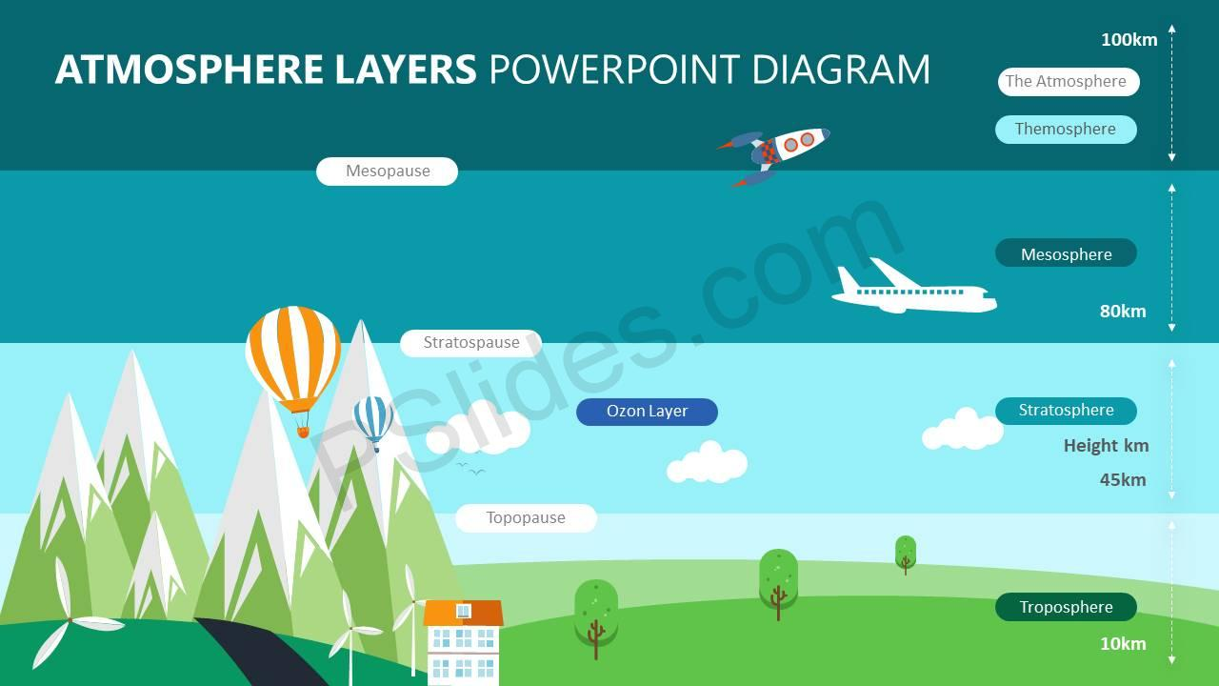
  - Troposphere
  - Stratosphere
  - Mesosphere
  - Thermosphere
  - Exosphere
Draw in your notebook the temperature’s variation related to the altitude:
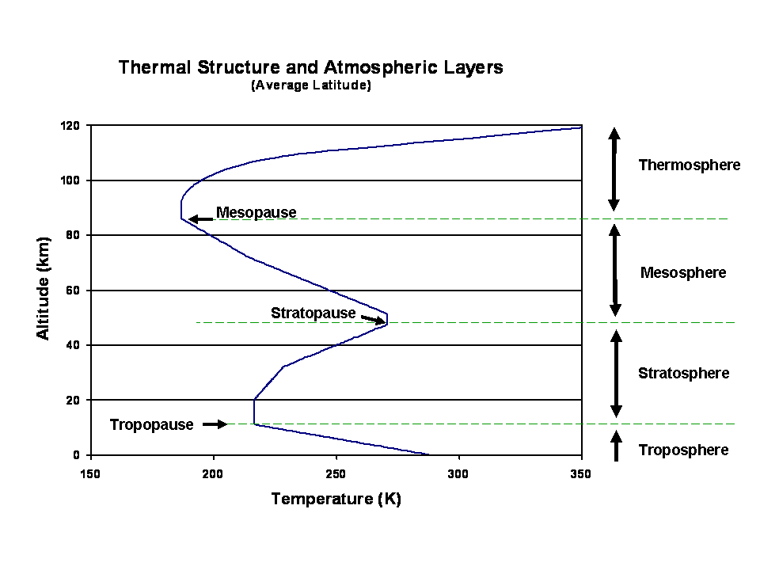

Convert ºC into Kelvin
ºC= K - 273
  - In which layers does the temperature increase? And why do you think it could be?
  - Activity 2 pg 79

- The importance of the atmosphere for the living things.
  - Use of gases:
Watch the video https://www.youtube.com/watch?v=PMenuLJmV0I
    - Aerobic living things breathe in oxygen and breathe out carbon dioxide.
    - Algae and plants take in carbon dioxide and release oxygen in photosynthesis
    - Nitrogen is taken by soil bacteria that change its form so that plants can use it.
  - Water cycle. Pag 80_ clouds
  - Protection from solar rays: gamma and x-rays (thermosphere) and UV rays (stratosphere)
  - Greenhouse effect is a natural process that warm the Earth’s Surface. Essential for life. If it did not exist, the average temperature would be – 18ºC, when actually is 15ºC.
https://www.environment.gov.au/climate-change/climate-science-data/climate-science/greenhouse-effect

Greenhouse effect
Step 1: Solar radiation reaches the Earth's atmosphere - some of this is reflected back into space.
Step 2: The rest of the sun's energy is absorbed by the land and the oceans, heating the Earth.
Step 3: Heat radiates from Earth towards space.
Step 4: Some of this heat is trapped by greenhouse gases in the atmosphere, keeping the Earth warm enough to sustain life.
What are the greenhouse gases?
https://climatekids.nasa.gov/greenhouse-effect/
Step 5: Human activities such as burning fossil fuels(coal, oil and natural gas), agriculture / livestock and land clearing (deforestation) are increasing the amount of greenhouse gases released into the atmosphere.
Step 6: This is trapping extra heat, and causing the Earth's temperature to rise.
The rise in temperature can produce:
Melting the polar ice caps and rising the sea level, causing floods in coastal areas
Changes in the climate: rise in droughts, floods and hurricanes
Plagues of insects and extinction of many species.
EGG IN A BOTTLE EXPERIMENT

Mind Map about atmospheric pollution

ATMOSPHERIC POLLUTION
POLLUTION EFFECTS
AIR POLLUTANS
AIR POLLUTANS ORIGIN
PARTICLES IN SUSPENSION:

NATURAL:

HEALTH
ENVIROMENT

GASES:

MAN-MADE:

Texts to put into the boxes:
Respiratory problems and allergies  Oxides of carbon (CO₂, CO)  Volcanic eruptions  Pollens grains  SMOG  Fossil fuels (petrol, coal, gas)  Forest fires  Smoke  Affects vegetation and aquatic organisms  Electrical storms  Sulfur compounds | A cloud of pollution which hangs over cities.  ACID RAIN  Nitrogen oxides  Cattle_Livestock  Rise in droughts, floods, fires and hurricanes  OZONE DEPLETION increases UV radiations levels  Stagnant water  Acid compounds formed after reacting with water vapour in clouds and can fall as rain long away. | Increasing of the greenhouse effect.  Rice production  Hydrocarbons (CH4)  Ash  Fertilizers  Plagues of insects and extinction of many species  Halogen compounds  Industries  Global warming  Increases in certain types of skin cancers, eye cataracts and immune deficiency disorders

ATMOSPHERIC POLLUTION
POLLUTION EFFECTS
AIR POLLUTANS
AIR POLLUTANS ORIGIN
PARTICLES IN SUSPENSION:

NATURAL:

HEALTH
ENVIRONMENT
SMOG

Pollens grains
Smoke and Ash

Volcanic eruptions
Forest fires
Electrical storms
Stagnant water

Respiratory problems and allergies

A cloud of pollution which hangs over cities.
GASES:

Affects vegetation and aquatic organisms
Respiratory and cutaneous problems

Acid compounds formed after reacting with water vapour in clouds and can fall as rain long away.
ACID RAIN

Oxides of carbon (CO₂, CO)
Nitrogen oxides
Sulfur compounds
Hydrocarbons (CH4)
Halogen compounds

Forest fires
Fossil fuels (petrol, coal, gas)
Fertilizers (chemical substances)
Cattle_Livestock
Rice production
Industries

MAN-MADE:

Increasing of the greenhouse effect.

Global warming

Plagues of insects and extinction of many species
Rise in droughts, floods, fires and hurricanes

Increases in certain types of skin cancers, eye cataracts and immune deficiency disorders
OZONE DEPLETION increases UV radiations levels

