**Unit 2: The earth and the Moon**

Outlines

CONDITIONS FOR LIFE ON EARTH

* The planet receives enough energy to allow water to exist as a liquid on its surface. It’s due to:
  + The right distance from the Sun (if too far, ice, if to close vapour)
  + The atmosphere prevents heat loss at night.
* The Sun light is a source of energy as fuel to the living things.
* Protection from solar flares because of the Earth’s magnetic field.
* Protection from solar harmful rays thanks to the existence of an ozone layer.
* The planet has a big moon stabilizing its axial woblble.

EARTH’S MOTIONS IN SPACE

* Rotation:
  + On its axis in anticlockwise direction
  + 24 h a full rotation
  + It produces day and night
* Revolution:
  + Around the Sun following an elliptical orbit.
  + 365 days, 6 hours and 9 minutes, a sidereal year
  + Calendar is corrected adding 1 day each 4 years.
* Revolution motion and the Earth’s axis tilt produce:
  + Seasons: Summer in the Northern hemisphere when closer to Sun. Winter in the Southern. Winter, the opposite.
  + Variation in the number of daylight hours during a year: When winter, fewer hours (sunrise later and sunset earlier). Summer, the opposite.

Page 42. Activity 1.

Page 43: look carefully at the picture about the seasons while 1 minute and then do activity 2. After this, activity 4.

Page 41: Reading and Watching some videos about geocentrism and heliocentrim. Answer ac. 1.

<https://www.youtube.com/watch?v=iiBIFlvu-X0>

Page 44

We are going to make a diagram about the 4 Earth spheres.

We will use colored cards for each sphere that we will stick on the notebook as a window to lift and write below the most important features.

Oral exposition: I will ask about one of the 4 spheres to each one. Rúbrica: oral exposition

**Outlines about The Moon. ANSWER THESE QUESTIONS**

* It appears to shine because it reflects the Sun’s light.
* There are many large plains called seas and many craters on its surface.
* There is not atmosphere, so the Moon temperature is higher than the Eart’s at day and lower at night.

What causes craters?

What is lunar regolith? Write the kind of rocks it is.

* The Moon rotates at the same speed as it orbits the Earth. We only see one side of the Moon.

Try to model this with a partner.

Why does the distance between the Earth and the Moon change?

What is the name for the closest point and for the furthest point?

* The time from one full moon to the next is 29.5 days. Is the lunar month. There are 12 lunar month by a lunar year .

¿When can you see a supermoon?

* The lunar phases:

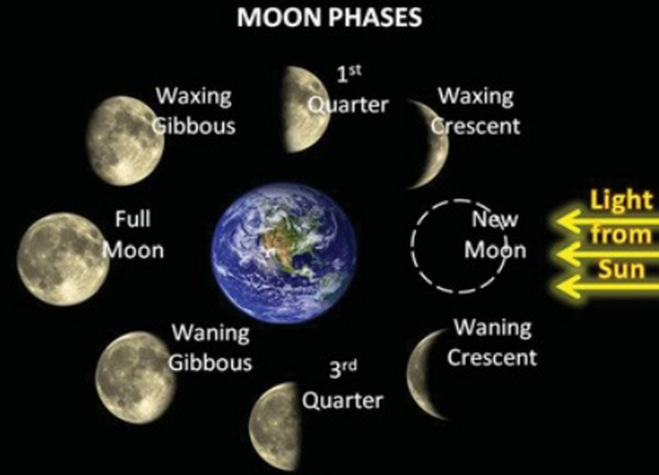**The eight phases of the Moon in order are:**

* **new Moon**
* waxingcrescent Moon
* **firstquarter Moon**
* waxinggibbous Moon
* **full Moon**
* waninggibbous Moon
* **lastquarter Moon**
* waningcrescent Moon

Investigate what a blue Moon is

Write the name of the Moon’s phases



Identify these Moon’s phases:

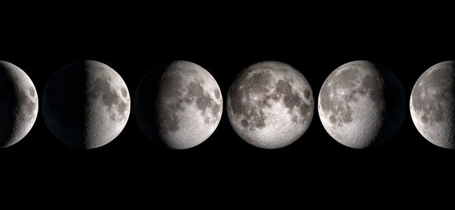

* Read pag 49. Filling the gaps.

An eclipse is an astronomical event where one celestial body partially or completely hides another one. Sun, Earth and Moon have to be aligned. It only occurs at two points: when the orbital path of the Moon crosses the ecliptic plane (plane of the Earth’s orbit)

* + Solar eclipse:
    - When the Moon is between the Earth and the Sun.
    - Can be total, partial or annular.
    - Total solar eclipses are rare..
    - They last only few minutes.
    - They can only be seen from few places on Earth.
  + Lunar eclipse:
    - When the Earth is between the Moon and the Sun.
    - Lunar eclipses are frequent
    - Can be seen from an entire hemisphere.
* Spring and neap tides. After watching a video (<https://www.youtube.com/watch?v=HdI_PyMFNro> ) answer these questions:

1. What causes the tides?
   1. The Moon’s gravitational force pulling on the Earth and its oceans with different strengths
2. What is the strongest pull?
   1. On the nearside ocean because it is the closest
3. Why the New Moon is invisible?
   1. We can only see its dark night side
4. How many days takes the Moon to its first quarter position?
   1. 7
5. When can we see the first quarter position, at day or at night?
   1. Half day and half night
6. What is the spring tide? When occurs it?
   1. It is a stronger tide when the Sun and the Moon are aligned. When full or new Moon.
7. What is the neap tide? When occurs it?
   1. s a lower tide when the three celestial bodies are situated at right angle. First and third quarter.
8. How many high tides and low tides are in 24 hours, in one month? How many spring tides and neap tides are each month?
   1. 2 of each one in a day. 60 of each one in a month. 2 of each one.

* Spring and neap tides. After watching a video (<https://www.youtube.com/watch?v=HdI_PyMFNro> ) answer these questions:
  1. he Moon’s gravitational force pulling on the Earth and its oceans with different strengths

1. What causes the tides?
2. What is the strongest pull?
   1. On the nearside ocean because it is the closest
3. Why the New Moon is invisible?
   1. We can only see its dark night side
4. How many days takes the Moon to its first quarter position?
   1. 7
5. When can we see the first quarter position, at day or at night?
   1. Half day and half night
6. What is the spring tide? When occurs it?
   1. It is a stronger tide when the Sun and the Moon are aligned. When full or new Moon.
7. What is the neap tide? When occurs it?
   1. S a lower tide when the three celestial bodies are situated at right angle. First and third quarter.
8. How many high tides and low tides are in 24 hours, in one month? How many spring tides and neap tides are each month?

**Activity: The Orbit Tellerium.**

1. Earth’s axis tilt in a constant direction.
2. The plane of the Moon’s orbit around the Earth is at an angle of 5º to the Earth’s orbit plane (The ecliptic).
3. If you are looking down to the North Pole, rotate the Earth anticlockwise around the Sun. Moon too. Earth axis too.
   1. First position of solstices (Winter and summer)
   2. Second position of equinox (spring and autumn)
4. Locate Spain. Observe where is before the sunrise and the sunset? (East coastal)
5. Look at the North Pole in summer and in winter: continuous day light or darkness.
6. Observe the length of daytime and the tilt of the Sun rays in Spain. More of the Earth’s surface in your hemisphere is in sunlight than in darkness. Days longer than nights in summer.
7. Where are the Sun’ rays perpendicular in summer/winter (Tropics) and in spring/autumn (Equator)?
8. At the spring equinox, days and nights are of equal length at all latitudes. The line of day/nights passes through the Poles.

**ABOUT MOON POSITIONS. Change Earth to the smaller blue sphere and put the large Moon.**

1. From new Moon to First quarter: Half Moon and half Earth illuminated. An observer on Earth usually only sees lit areas of the Moon because the unlit area is too dark to see. 7 days.
2. Move the Moon to the crescent, gibbous and full Moon. When you see the Moon getting bigger in the night sky you are seeing more and more of its illuminated surface. This growing Moon is called waxing Moon. You can see the waxing Moon from day to night. Full Moon at night.
3. Move the full Moon to third quarter. 7 days. You are seeing less and less of its illuminated surface. It is calling waning Moon. From night to day. At night you can’t see the Moon because it is at the other side of the Earth. At day, you cannot see the dark side of the Earth.

**ABOUT ECLIPSES. Change large Moon to small Moon.**

**See the shadow projected to the wall.**

1. Solar Eclipse: the Moon between the Sun and the Earth. It is required the Moon in its New Moon phase. The shadow of the Moon not covers the whole of the Earth’s surface. At any one time a small part of the Earth may be in total eclipse, another small part in partial eclipse, most will not be eclipsed. So what an observer sees is depending on their location.
2. Moon Eclipse: the Earth between the Sun and the Earth. It is required the full Moon. Anyone able to see the Moon during that time will see the eclipse.
3. Eclipses don’t occur each month. The plane of the Moon’s orbit is inclined at an angle to the plane of the Earth’s orbit. The Moon crosses the Earth ‘orbit approx every six months.