Initial activity: Video about the origin of the Universe.
https://www.youtube.com/watch?v=GncYOf29uc4

- What is the Big Bang Theory?
- How old is the Universe? Write the complete number.
- It was thousands times smaller than a _______
- What was born after the explosion?
- What was the first atom?
- How is called the single concentrated point or bubble which later became to the universe?

- What is the Big Bang Theory? It is a theory about the origin of the Universe.
The Big Bang theory says that the Universe was created by a big explosion.
- How old is the Universe? Write the complete number.
Scientits say that the Universe is 13.787.000.000 years old
- It was thousands of times smaller than a _pinhead_.
- What was born after the explosion?
Time, space and matter came into existence
- What was the first atom?
When the Universe cooled enough to allow the protons and the neutrons come together and form the first atom: Hydrogen
- How is called the single concentrated point or bubble which later became to universe?
It was call the primeval atom or the cosmic egg

- Read pg 20 The origin of the Universe-

Answer these questions reading text book
- What is the composition of the Universe?
The composition of the Universe:
Normal matter: 5%
Dark matter: 25% Made up of material that scientists cannot directly observe
Dark energy: 70% Explain the expanding of the Universe.
- What is a nebula?
Nebulae are cosmic interstellar clouds made up of gas, dust and stellar debris. Stars are formed in them
- What is a galaxy? (give one example of Galaxy)

Galaxies contain star cluster, nebulae and black holes. Each galaxy has billions of stars, many with planetary systems.
There are billions of galaxies, sometimes grouped into galactic clusters.
The milKy Way is the Galaxy where our solar system is located.

The size of the Universe: https://www.youtube.com/watch?time_continue=154&v=1Eh5BpSnBBw

- What is an Astronomical Unit (A.U)?

It is a unit of measurement used to measure enormous distances. 1 AU= 150 million kilometer. It is the distance between the Earth and the Sun,
- What is a light year?
. 1 light year is the distance that light travels in a year at the speed of 300.0000 kilometers per second.
- Does a light year measure time or distance? It is a unit of measurement used to measure enormous distances
- What is bigger one Astronomical Unit or one light year?
1 light year.
Read the paragraphs about stars on page 22 and answer questions a and b.
Stars have spherical shapes.
Stats vary in their color (blue, white, red or yellow, depending on their temperature), in size and brightness. Their brightness and temperature depending on their mass.
Read “the evolution of stars” on page 23 and answer questions e and f.
A supernova is the explosion of a red supergiant, a star very large,.
When the Sun turns into a red giant could absorb nearby planets as the Earth.
Listening ex 2.
Read “A star called the sun” on page 24 and answer
- What are the movements of the Sun?
The Sun rotates on its axis every 27 days in an anticlockwise direction and orbit around the center of the galaxy at about 20 km per second.

- Do letter a and b
In the Sun nuclear reactions take place in which two hydrogen atoms fuse to create helium atoms, and that releases huge amount of energy
Read 25 and listening ex 1 and 3
Page 28
Read and answer letter a.
What is a planet?
A planet is a spherical body orbiting the Sun along an elliptical path, no sharing it with other planetary bodies.
Differences between inner and outer planets:
Inner planets: Mercury, Venus, the Earth and Mars  Closest to the Sun  Rocky  Small in size  None or few natural satellites | Outer planets: Jupiter, Saturn, Uranus and Neptune.  Farthest  Gaseous with a rocky core  Largest  Rings and lots of satellites

Dwarf planets. Read and letter b
Differences from other planets:
Spherical bodies orbiting the Sun along an elliptical path, sharing it with other planetary bodies.
Natural satellites: what is a natural satellite?:
Small bodies orbiting planets.
https://www.nationalgeographic.com/science/2019/10/discovery-20-new-moons-gives-saturn-solar-system-record/#targetText=Discovery%20of%2020%20new%20moons%20gives%20Saturn%20a%20solar%20system%20record&targetText=In%20October%202016%2C%20NASA's%20Cassini,planet's%20total%20up%20to%2082.

We are going to make a model of our Solar system
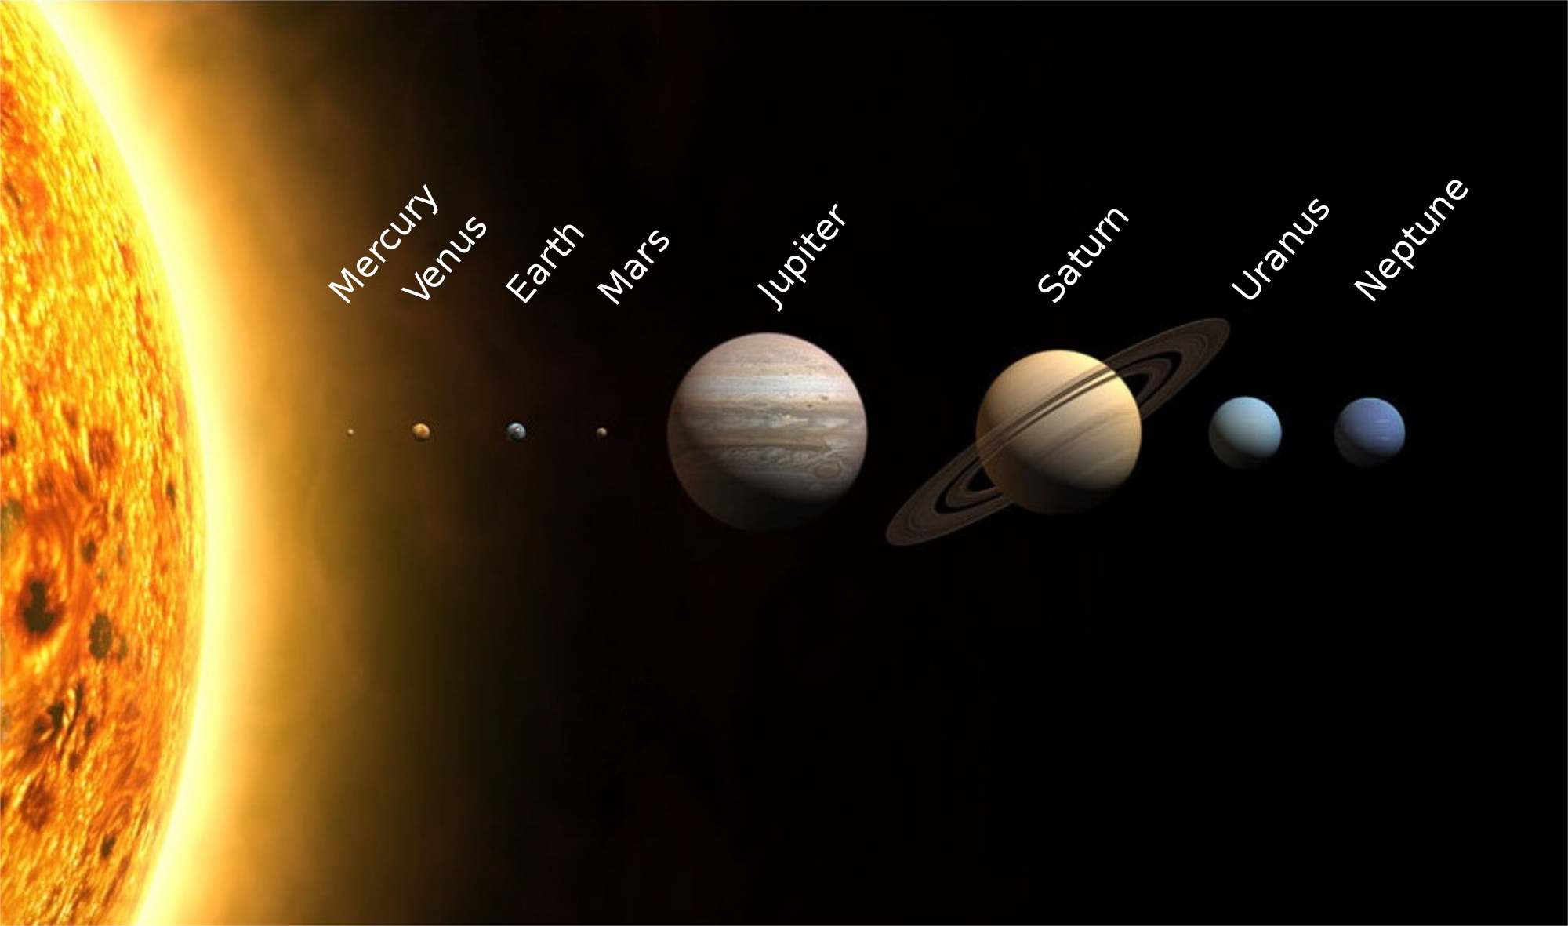

We need the sizes of the planets and their distances from the Sun in AU
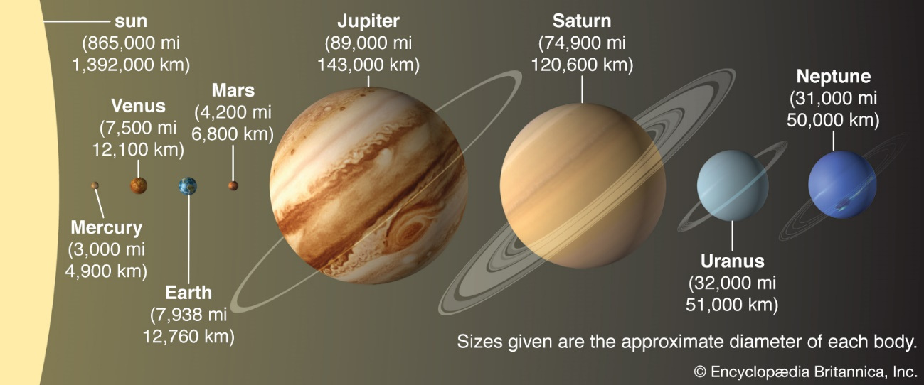
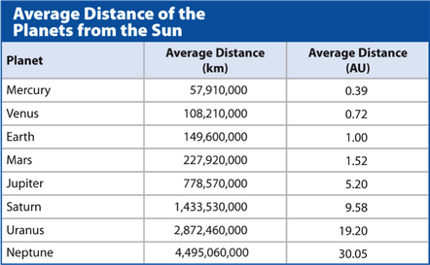
We will take the size of Earth as 2.5 cm and need relate the sizes of the other planets. Page 30 and 31. Calculate it using Excel.
We will take 1 AU as 9 cm. We have to calculate in how many centimeter we have to put the different planets
https://www.solarsystemscope.com/textures/

Characteristics and curiosities about the planets
https://www.universetoday.com/33415/interesting-facts-about-the-planets/
https://space-facts.com/planets/
https://theplanets.org/planets/
https://www.kidzone.ws/planets/

Calculations
Now, show your calculations for URANUS planet below:
If the Real diameter of Earth 12,760 km (12,760,000 m) and the Scaled diameter is 2.5 cm (0.025 m).
What is the Scaled Diameter of URANUS? (Uranus´real diameter is 50,720 km = 50,720,000 m)
CONCLUSION QUESTIONS
1. Which are the two largest planets?

2. Which planet is closest in size to Earth?

3. Knowing that Jupiter’s diameter is 143,000 km, how many times greater than Earth’s diameter is? (approximately)

4. If we place the Earth 9 cm away from the Sun, where should we place Pluto in that scale model, knowing that its average distance is 39.5 AU.?

Calculations
Now, show your calculations for URANUS planet below:
If the Real diameter of Earth 12,760 km (12,760,000 m) and the Scaled diameter is 2.5 cm (0.025 m).
What is the Scaled Diameter of URANUS? (Uranus´real diameter is 50,720 km = 50,720,000 m)
CONCLUSION QUESTIONS
1. Which are the two largest planets?

2. Which planet is closest in size to Earth?

3. Knowing that Jupiter’s diameter is 143,000 km, how many times greater than Earth’s diameter is? (approximately)

4. If we place the Earth 9 cm away from the Sun, where should we place Pluto in that scale model, knowing that its average distance is 39.5 AU.?

