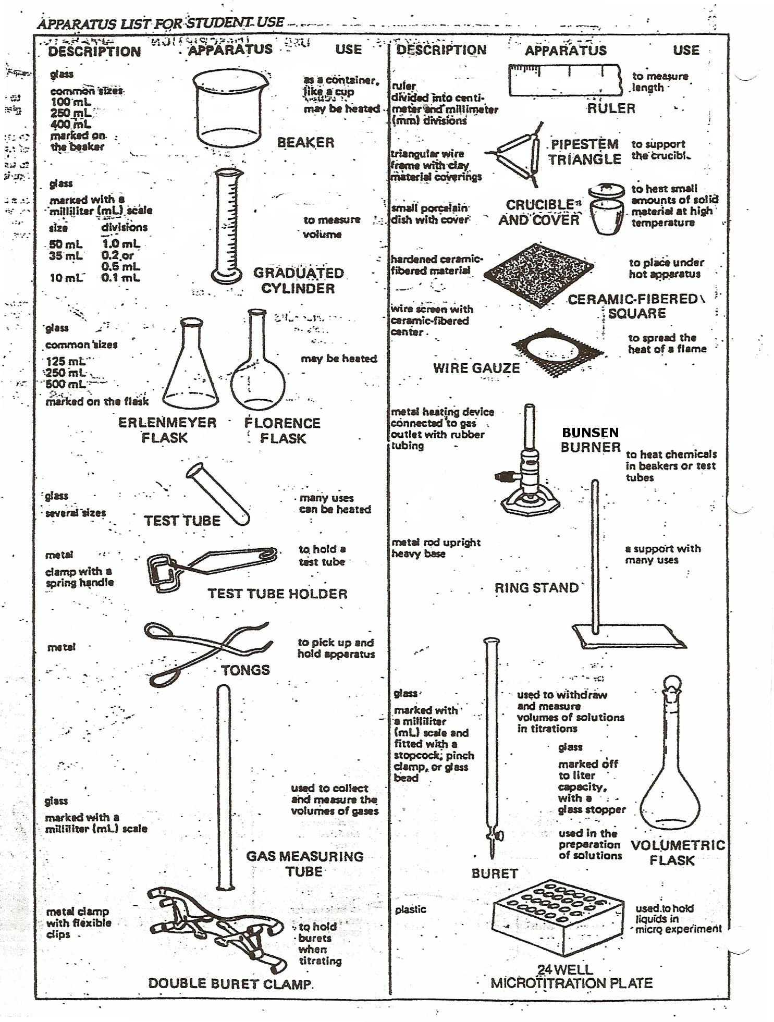
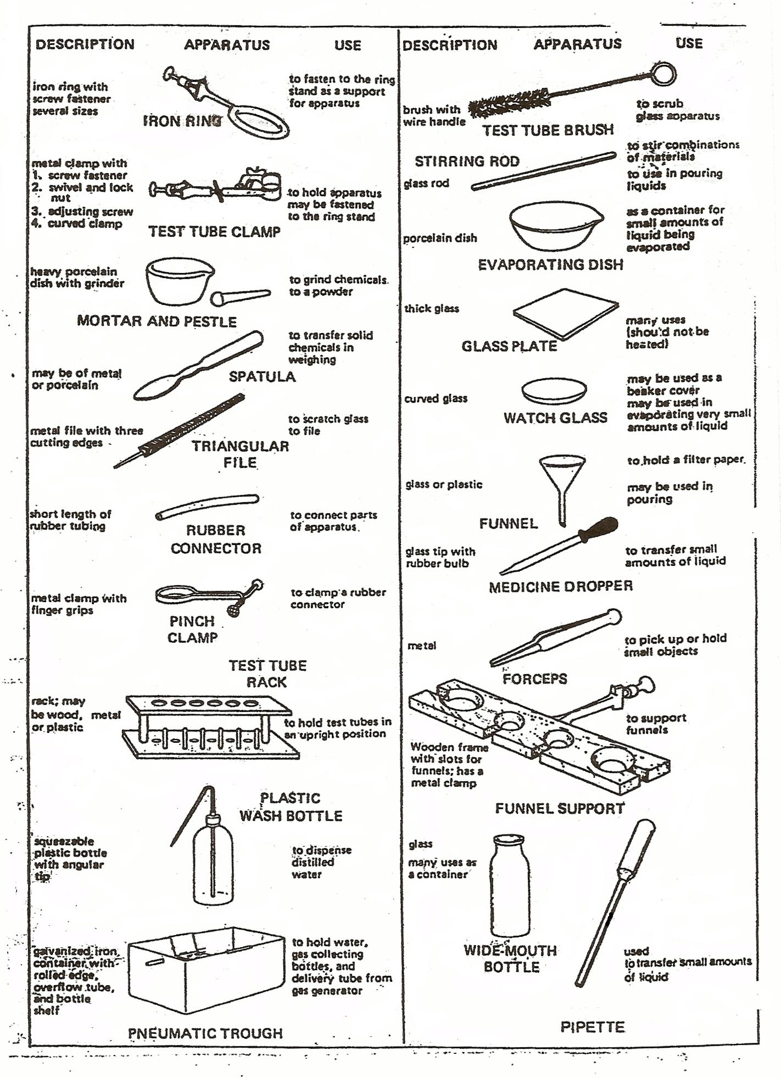
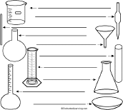

Label the glass laboratory equipment using the terms below.

beaker - A cylindrical flask with a flat bottom.
Erlenmeyer flask - (Also called conical flask) A flask with a conical body, a cylindrical neck and a flat bottom.
filter funnel - a glass funnel used with a paper filter; it is used to separate solids from liquids.
Florence flask - A flask with a spherical body and a cylindrical neck.
graduated cylinder - A cylindrical container used to measure volumes of liquid.
stirring rod - A glass rod used to stir liquids.
test tube - A long, cylindrical glass container; it is open at the top and has a rounded bottom.
volumetric flask - A flask with a cylindrical neck, a spherical body and a flattened bottom; it is used to measure and store precice amounts of liquid.
volumetric pipette - A glass tube used to transport a small, measured amount of liquid.
watch glass - A shallow, rounded dish used to evaporate liquids or cover a beaker.

