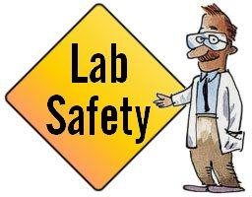
RULES

Be Prepared:
Before you enter a biology lab, you should be prepared for and knowledgeable about any lab exercises that are to be performed. That means you should pay attention and read the lab instructions to know exactly what you will be doing.
Review your biology notes and relevant sections in your biology book before your lab begins. Make sure you understand all procedures and purposes, as this will help you understand the lab activities you will perform.
Report every practice in your notebook with a Lab Report.
It will also help you get your thoughts organized for when you have to write your LAB REPORT. This LAB REPORT will always include sections as:
- Title of the practice.
- Date.
- Material: Lab equipment used (with name and drawings)
- Procedure (Explain what you have done during the practice).
- Results and/ or conclusion.
Be Neat:
When working in a biology lab, make sure you keep your area neat and organized. If you happen to spill something, ask for assistance when cleaning it up. Also remember to clean your work area and wash your hands when you are finished.
Be Careful:
An important biology lab safety rule is to be careful. You may be working with glass or sharp objects, so you don't want to handle them carelessly.
Wear Proper Clothing:
Accidents do happen in a biology lab. Some chemicals have the potential to damage clothing. With that in mind, you want to make sure that the clothing you wear is something you could do without if it becomes damaged. As a precaution, wearing an apron or lab coat is a good idea.
Be Cautious With Chemicals:
The best way to remain safe when dealing with chemicals is to assume that any chemical you handle is dangerous. Be sure you understand what type of chemicals you are using and how they should be properly handled.
If any chemical comes in contact with your skin, wash immediately with water and inform your lab instructor. Wear protective eyewear when handling chemicals.
Report all class injuries to the teacher regardless of how minor they might appear.
Locate Safety Equipment:
Be sure you know where to find all safety equipment in the biology lab. This includes such items as the fire extinguisher, first aid kit, broken glass receptacles, and chemical waste containers. Also be sure you know where all the emergency exits are located and which exit route to take in case of an emergency.
Biology Lab Don'ts:
There are several things in a biology lab that you must always avoid. Here are a few major laboratory do nots.
Do Not
- eat or drink in the lab
- wear long scarves or clothes or objects that hinder your mobility.
- taste any chemicals or substances you are working with
- use your mouth for pipetting substances
- handle broken glass with bare hands
- pour chemicals down the drain without permission
- operate lab equipment without permission
- perform your own experiments unless given permission
- leave any heated materials unattended
- place flammable substances near heat
- walk from one place to another for no reason neither run inside the laboratory or push another partner.
- engage in childish antics such as horseplay or pranks
Do
- Put your backpacks at the bottom of the class and never leave them on the work table.
- If you have long hair, pick it up.
- Have only the books and notebooks that are necessary on the table.
- Always keep your hands clean and dry. If you have any injuries, cover it.
- To hold the glass instruments and remove it from the fire, use wooden tweezers. When you heat the test tubes with the help of these tweezers, try to give them some inclination. Never look directly into the tube or direct it towards a partner.
Have a Good Experience:
Biology lab is an important aspect of any biology course. In order to have a good lab experience, make sure that you follow these biology lab safety rules and any instructions given to you by your lab instructor.
http://biology.about.com/od/biologylabhowtos/p/labsafety.htm

http://www.biologyjunction.com/picturing%20lab%20safety.html
View the picture and answer the questions concerning lab safety.
Questions:
1. List 3 unsafe activities shown in the illustration and explain why each is unsafe.

2. List 3 correct procedures depicted in the illustration.
3. What should Bob do after the accident?
4. What should Sue have done to avoid an accident?
5. Compare Luke and Duke's lab techniques. Who is following the rules?
6. What are three things shown in the lab that should not be there?
7. Compare Joe and Carl's lab techniques. Who is doing it the correct way?
8. What will happen to Ray and Tim when the teacher catches them?
9. List three items in the illustration that are there for the safety of the students in the lab.

10. What is Betty doing wrong?

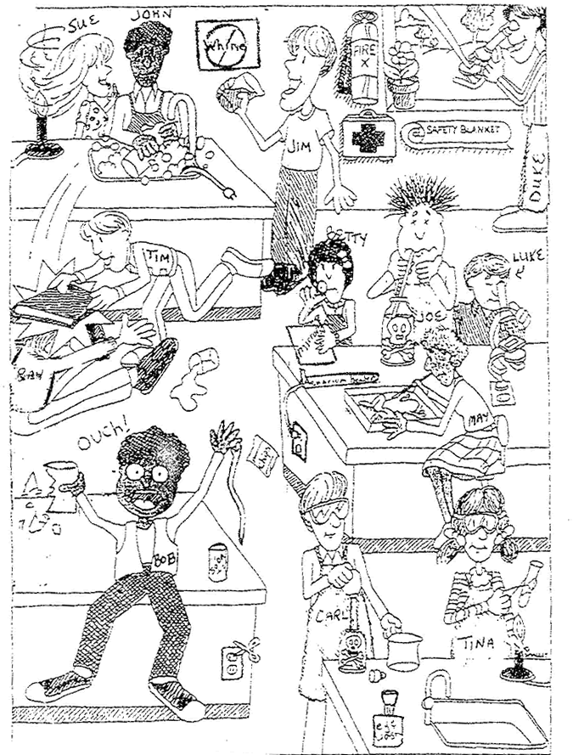

The chemical risk symbols are pictograms that are stamped on the labels of the chemical products and that serve to give an instant perception of the type of danger involved in the use, handling, transport and storage of these.
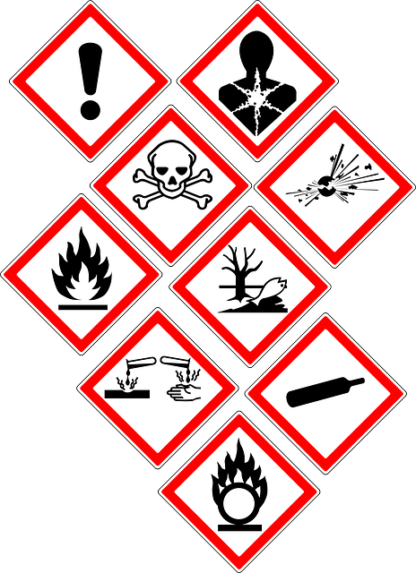
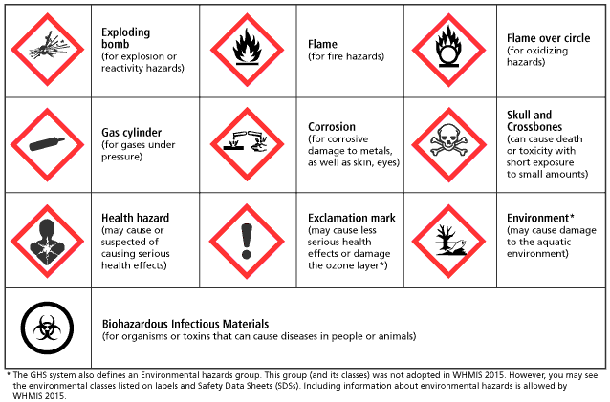
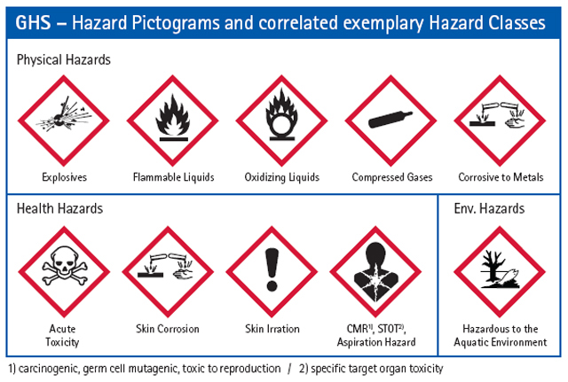

Relate each pictogram to the word and the corresponding concept. Write it under each pictogram

Explosive Corrosive Oxidizing liquid Compressed gases Exclamation mark Hazardous to the aquatic environment Health hazard Flammable liquid Acute toxicity

For explosion or reactivity hazards
For fire hazards
For oxidizing hazards
For corrosive damage to metals, as well as skin, eyes, ….
Can cause death or toxicity with short exposure to small amounts
May cause or suspected of causing serious health effects: carcinogenic, germ cell mutagenic, toxic to reproduction
May cause less serious health effects or damage the ozone layer
For gasses under pressure
May cause damage to the aquatic environment

